1. **Copyright Notice & Disclaimer:**

The original source code was (and at time of writing, is) distributed freely through the Department of Molecular and Cellular Physiology at Stanford University (<http://wormsense.stanford.edu/tracker/>). The authors of this update make no copyright claim to any modifications to the WormTracker or WormAnalyzer functions, which are © 2008 Daniel Ramot and Miriam B. Goodman. These modifications of the WormTracker and WormAnalyzer code are thus subject to the same conditions on the original software:

(1) The package and portions thereof may not be sold. Users may modify the software for their own use, but may not redistribute any version of the software other than the original version without the express permission of the author and Stanford University.

(2) This software package is provided on an “as is” basis. The author in no way warrants either this software or results it may produce. Use of this software is at your own risk.

(3) The author is under no obligation to provide any services by way of maintenance, updates or corrections for this software.

(4) Reports or publications resulting from use of this software package must contain an acknowledgement in the form commonly used in academic research. For citing the software, please cite [Ramot et al. (2008, PMID 18493300)](http://www.ncbi.nlm.nih.gov/pubmed/?term=parallel%20worm%20tracker). If citing the experimental setup, please cite Mouchiroud L., Sorrentino V. *et al.*, **The Movement Tracker: A Flexible System for Automated Movement Analysis in Invertebrate Model Organisms.**

TransferTracks is copyright © 2013 Evan Williams, Tarik Ouhmad, Johan Auwerx, but it is freely available for all commercial and academic purposes.

1. **Brief Description of the Software:**

This software package is a modification and update to the Parallel Worm Tracker by [Ramot et al. (2008, PMID 18493300)](http://www.ncbi.nlm.nih.gov/pubmed/?term=parallel%20worm%20tracker). Significant changes include: updates to the code for more recent MatLab versions (e.g. removing deprecated function calls), generalizing the software to different experimental setups, and increasing analytical throughput for measuring the movement of large quantities of worms and flies on a regular basis and in different experimental setups.

The package contain one module with three elements: (1) a “MovementTracker” module for viewing and tracking, (2) a “ObjectAnalyzer” module for analyzing tracks generated by the tracker software, and (3) a “TransferTracks” module for quickly synthesizing and analyzing all data from the tracks.

1. MovementTracker: This module identifies worms and flies by their center of mass (centroid), highlighting by a blue cross. This identification is based on regions of pixels’ darkness detection and size thresholds. Regions corresponding to the tracked animals (objects) are at high contrast to the rest of the plate objects. The program computes the object size and then movement of the centroid to track objects frame after frame. This centroid’s properties are set to Tracks File, which is the output of this module.
2. ObjectAnalyzer: “provides a user-friendly environment for viewing and analyzing tracks generated by the movement tracker”. The tracks can be displayed one by one and also played back if necessary. Then, for each track, the software calculates object speed, angular speed and direction and other features…

TransferTracks: We have generated the TransferTracks function to collate data from all objects tracks and display the parameters pulled from every individual in every plate, microfluidic chamber or walking chamber into an Excel file (.xls).

1. **Installation Instructions:**

This software is written in MATLAB, and the Image Processing Toolbox must be installed in order for this code to run (which is included on a standard installation). The initial software by Ramot et al. was written for MATLAB R2007a on Windows XP.

The update was written for MATLAB R2012a on 32-bit Windows XP, but also works fine with 32-bit version of MATLAB 2015b on 64-bit Windows 8 as well as MATLAB 2015b on OS X 10.10.5. (32-bit version of MATLAB should be used if we run the software on 64-bit Windows distribution. The issue is with the combination of the specific codec and 64-bit version of MATLAB)

After installation of MATLAB, download the MovementTracker.zip file included with this FAQ and the manuscript. Unzip the contained directory (“MovementTracker”) and put this in your MATLAB current working directory. To run the code, you will need to change your working directory to this folder, or install the functions globally (i.e. using pathtool).

**IV) Video Capture**

The first step for tracking is to record a video capture of the movement (NB: we have removed from the original Ramot et al. video recording MatLab program to increase compatibility across systems). While theoretically any digital camera with a strong macro objective and a fixed tripod could be used, we highly recommend a digital microscope with a controller connected to a computer for the sake of consistency. However, it may be beneficial to show a proof of concept of the tracking device with a more basic setup.

The input for the Movement Tracker can be a video file of any resolution, but the program will work best for most users at lower resolutions and lower image quality, e.g. a greyscale 640x480 AVI). Many movie formats can be used, some of which are platform-dependent (e.g. .WMF only works on pre-Windows 7 machines). We recommend recording as .AVI for maximum compatibility, although users may have success using .MPG, .MP4, .M4V, .MOV, .WMF, .ASF, and .ASX.

For movement in solid media, in which worms move fairly slowly and consistently, we recommend recording at 1 frame per second with a large field of view. For movement in liquid media (i.e. much faster, more erratic movement), higher frame rates may yield better results, but note this will increase processing time and will require some parameters in the Movement Tracker and Object Analyzer to be modified (discussed later). Once all movies for the experiment have been recorded, the files can be transferred to the MovementTracker for analysis.

Critical points: (1) record all movies for an experiment at the same, constant framerate. Some codecs will try to “optimize” frame rate to reduce file size, resulting in a variable framerate movie file. (2) record all movies for an experiment at the same light settings and same microscope zoom.

Example:

For our worm on solid medium setup, we used a Nikon SMZ1000 with a DS-Fi1 camera head linked to a DS-U2 controller, linked to a standard Windows XP computer via USB. The microscope light is turned to maximum and the magnification is turned to its lowest setting. Video is then displayed on the computer using the free (“F”) version of Nikon NIS Elements and contrast is optimized. The image is downsampled from 1280x960 to 640x480 at a capture speed of 4 frames per second. As this software does not allow direct recording of video, we use an external screen capture program, AutoScreenRecorder, for recording videos. Selecting the 640x480 region of the screen displaying the worms, we record 90 seconds of video at 1 frame per second. The files are labeled and saved in .AVI format.

There are many other recording possibilities: the original authors of the software used a Navitar zoom lens attached to a Sony video camera.

The most critical elements of this setup are (A) precise positioning, lighting, and contrast (B) a zoom setting with a wide field of view, preferably for the entire movement area of the worms, and (C) ease of use for the researcher, preferably with videos immediately captured and stored in a format that the Movement Tracker can use.

**V) MovementTracker:**

Once the video files are in the same directory as the MovementTracker, in MATLAB, you should change your active directory to the MovementTracker and type the following command in the Command Window: MovementTracker [and press return]

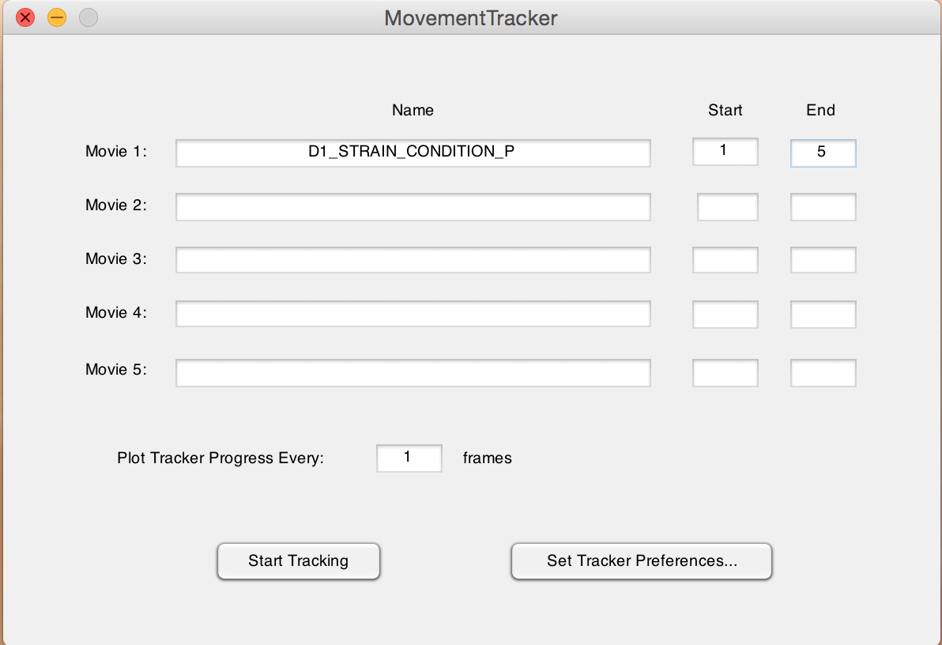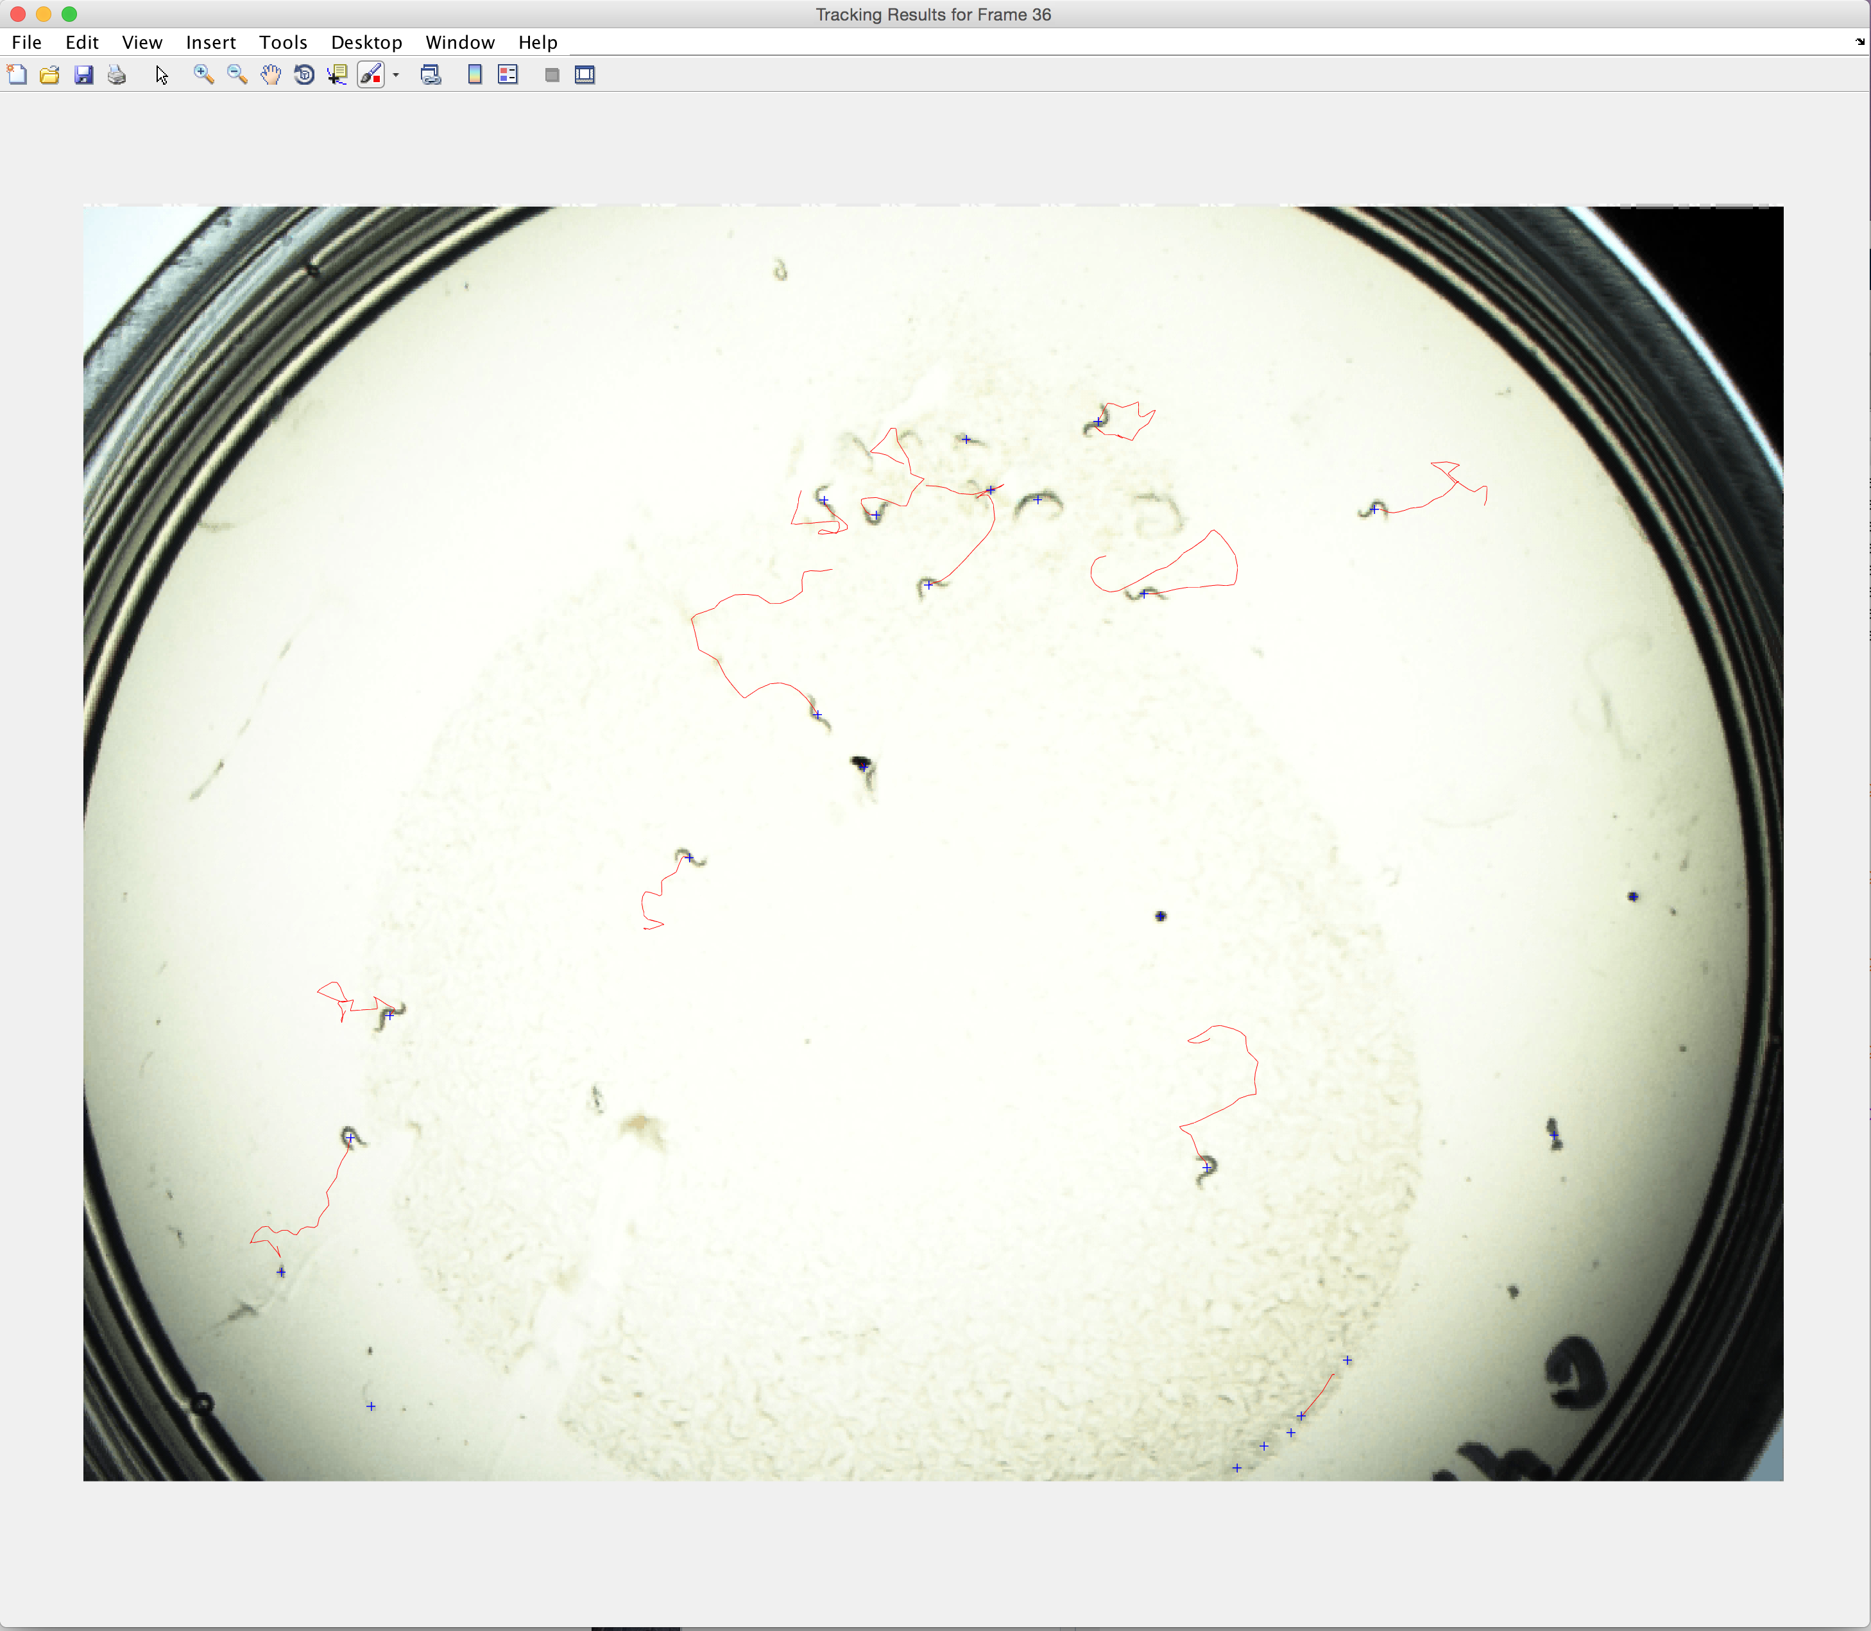After a moment, this user interface will show up, you can enter the video file name you want to track and also set the Tracker Preferences as in the example. Numerical increments follow the end of each “condition” so that potentially hundreds of videos can be tracked automatically and sequentially while the user is away.

However, before this is done, some key preferences must be modified according to each user’s experimental setup. Our standard experimental preferences are displayed here, but some elements will need to be modified for each user.

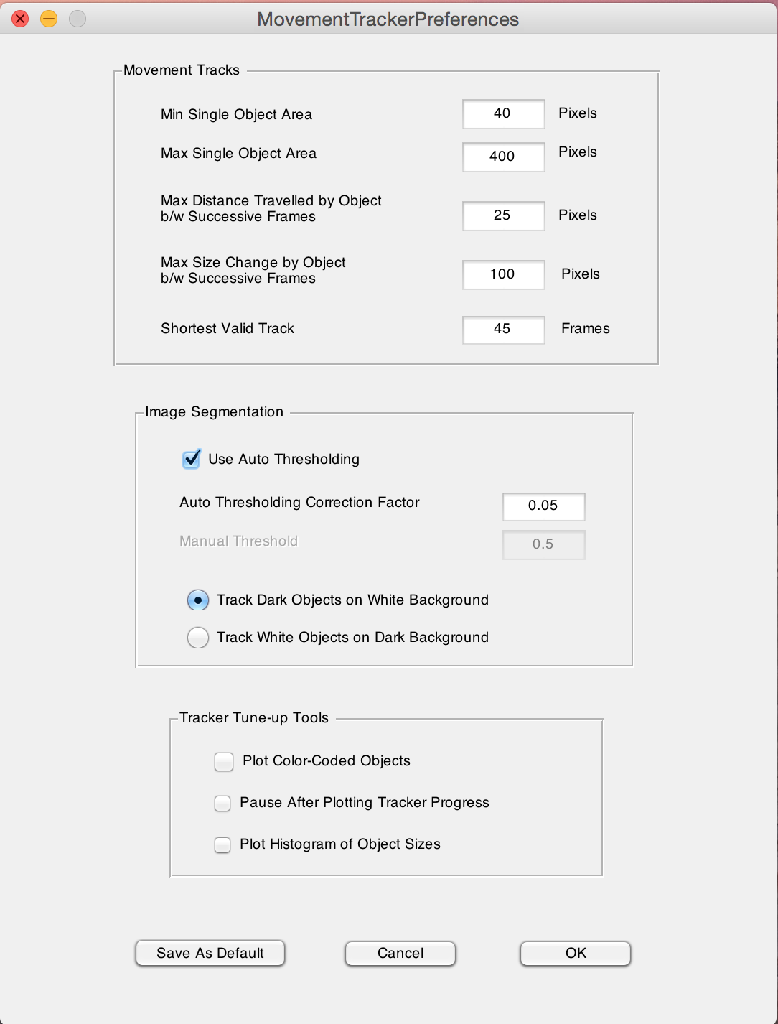

**Movement Tracks Parameters:**

1) **Min Single Object Area & Max Single Object Area:** These settings are thresholds for telling the program the size of your worm or fly, so it can exclude noise such as eggs or young individuals. These settings are highly dependent on (A) video resolution and (B) zoom. Higher zoom and resolution will increase the relative size of the object; thus videos recorded at different zooms or resolutions cannot be analyzed simultaneously. As a rule of thumb, the minimum object area is more important, as most noise is due to small objects; the settings here for the worm setup on solid medium (40 to 400) give almost exactly the same results as 40 to 4000. However, 10 to 4000 gives dramatically more false tracks.

2) **Maximum Distance Travelled by object between Successive Frames:** In solid mediums, or in recordings at reasonably high frame rates (≥1 fps), this parameter is not particularly important. However, in other cases, particularly liquid medium, this can ensure the program is tracking the same object over time. We recommend recording your videos at a high enough frame rate such that this parameter is a non-issue.

3) **Maximum Size Change by object between Successive Frames:** This setting allows the software to differentiate when two objects have intersected, versus when an object has simply slightly changed size (e.g. due to curling). In solid mediums, worms often change ±10% of their size in solid medium, and somewhat more in liquid medium. We recommend setting this value to 20-30% the average size of your target worms. For flies, this is a less important issue (they do not present any curling or bending).

4) **Shortest Valid Track:** Objects with a value under this threshold are discarded. This tool is useful to discard objects that were identified as worms or flies and they are not (e.g. a momentary speck in the camera). This can also be used to discard animals which were not on the recording long enough to give useful data; e.g. for the worm setup on plate, if 90% of the worms are on the plate > 45 seconds, it may be good to use a cutoff threshold of 45 seconds and eliminate worms which were not recorded long enough to give a reliable movement estimation.

**Image Segmentation Parameters:**

The first step of image segmentation is to convert the grayscale movie frame into a binary frame, which makes objects distinguishable. This conversion is done by setting a threshold (between 0 and 1) and this value is critical because the software uses this color value to distinguish objects from background.

1) **Use Auto Thresholding**:

2) **Auto Thresholding Correction Factor:**

‘To automatically calculate a starting value for each frame, select ‘Use Auto Thresholding’ (the default option). This allows for moderate lighting changes throughout the movie.

Then, you can obviously set the tracking mode (dark objects on a white background or white objects on a dark background).

**Tracker Tune-up Tools:**

1) **Plot Color-Coded Objects:** "In addition to the standard tracker progress frame, this option displays a color-coded map of all objects detected by the tracker." This is a useful tool to test the performance of the tracker and identify the object size in pixels.

2) **Pause after Plotting Tracker Progress:** you can select this option if you want to get some additional time to watch the tracking by directing from you key board the progression of the plot during the tracker tuning process.

3) **Plot Histogram of Object sizes:** This tool provides an additional plot during the tracking process that can help setting the 'Min Single object Area' and

'Max Single object area' parameters.

Once tracker parameters have been set, you can save them using the ‘Save As Default’ button*. This has as effect to set the ‘Movement Tracker Preferences.xls’ worksheet located in the MATLAB workspace folder.

Once your settings are adjusted and work for a variety of conditions, you can start the tracking. At the end of this process you get a matrix data file (.mat, and with the same file name as the video). This raw file contains the tracks of all points which the software (and your preferences) has determined to be “objects.” The tracks file and video file together form input for the Object Analyzer.

Note:

* If for many of your videos the structure you obtain (the .mat file) is an empty structure, you should change the tracking preferences and start the tracking again for all plates. If just a single video does not record tracks, simply discard that one.

**VI) ObjectAnalyzer:**

To run the tracking analysis, type “ObjectAnalyzer” in the MATLAB Command Window. On OS X, this cannot be performed while MovementTracker is actively analyzing. On Windows, you can perform both simultaneously, but you will need to open up another instance of MATLAB.

Once the ObjectAnalyzer GUI has loaded, all of the analysis can be performed from the ‘Tracks’ tab at the top of the menu.

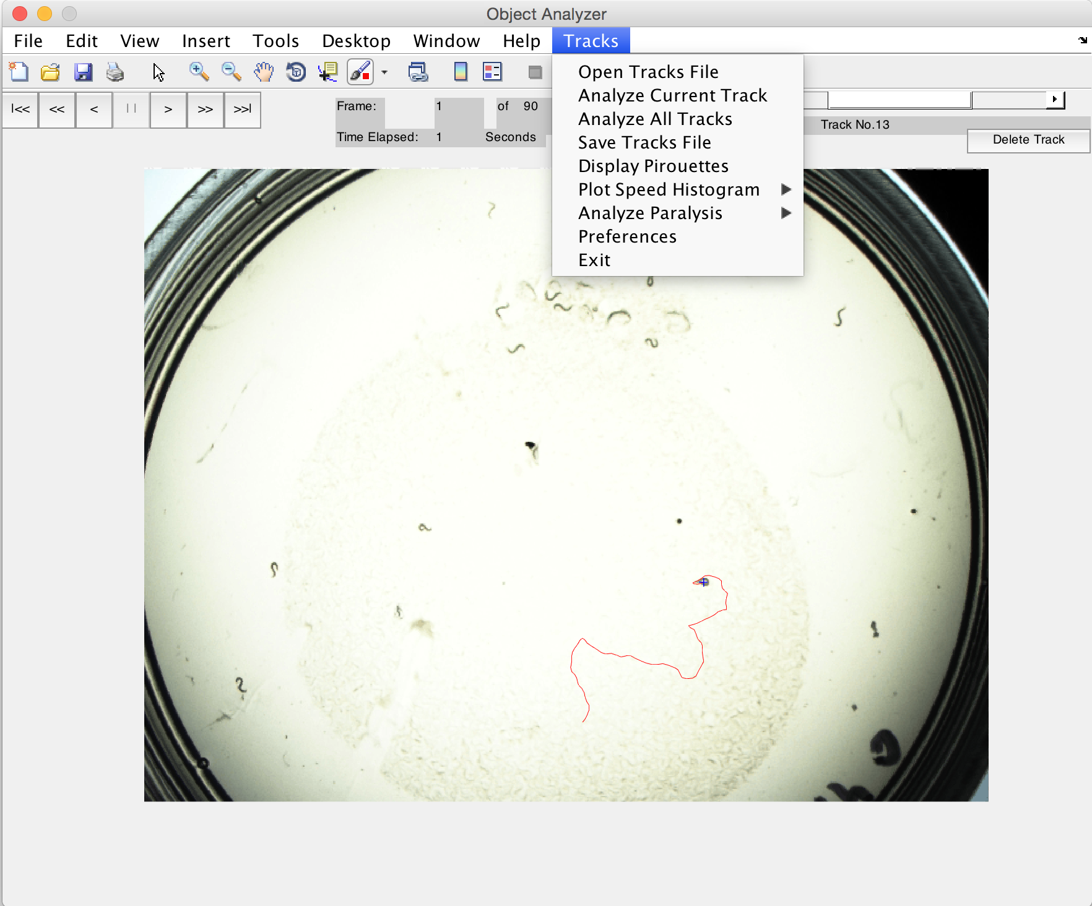

**1) Open Tracks File:** After you select the matrix file obtained by the MovementTracker, the corresponding video will load with the track of the ‘first’ worm drawn. If there are multiple objects, you will see a slider at the top right corner containing the tracks that can be displayed one at the time. Buttons on the top left allow you to scrub through the video for each individual track in forward or reverse at different speeds. If a track is incorrect (e.g. something other than a worm or fly is being tracked, or a dead animal is being tracked), you should delete this track.

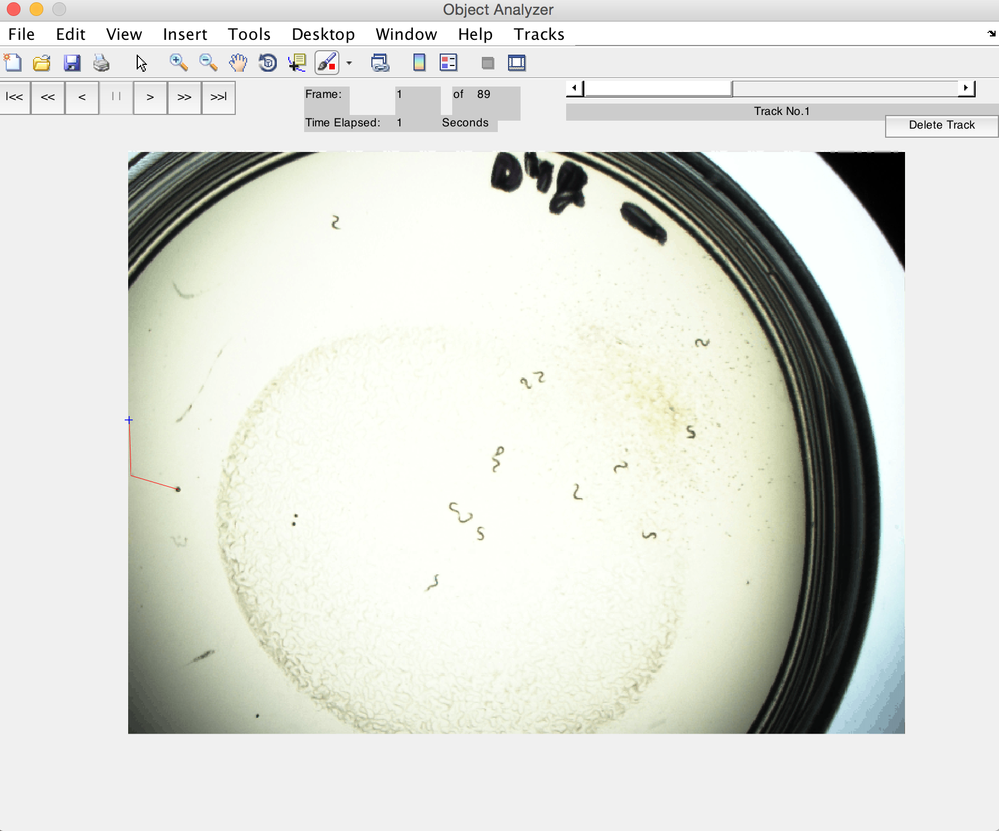

NB: Deleting the last track will result in a visual error where the slider will disappear and the track will remain displayed on screen. The track has been successfully deleted!

2**) Analyze Current Track:** For the selected track, the object’s movement characteristics are displayed graphically.

3) **Analyze All Tracks:** Analyses and saves all non-deleted tracks in the file and saves the results to a new file (by default, named with an “a” appended to the tracks filename).

4) **Save Track File:** Saves the single, selected track.

**Computing Pirouette Probabilities:** You first have to save all tracks associated with that movie. “To apply this analysis, select the file you saved after analyzing all tracks”. For each movie, the function calculates a: The number of objects being tracked; b: The number of tracked objects that could initiate a pirouette; c: The number of pirouettes initiated and d: the instantaneous pirouette probability (equal to c divided by b). “All four measures are plotted in order (top to bottom) against time in a single figure”.

**Plotting Speed Probability Distribution:** One of the option in the “Tracks” in the menu. “The output of this function are plots of objects speed probability density and cumulative distribution functions computed for the selected experiments”.

**Estimating the Fraction of Paralyzed animals:** Can be calculated using the ‘Analyze Paralyze’ option under the ‘Tracks’ menu. The output of this function are the fraction of paralyzed objects, average speed, the number of tracks analyzed. They can be displayed in MATLAB command window and also under the Excel file ‘AnaylsisResults.xls’

**Analysis Preferences:** Can be set using the option Preferences under the ‘Tracks’ menu. An interface shows up and contains settings you can modify.

Analyze & Display: Determines what parameters we want to measure and analyze when single Tracks are analyzed.

**Tracker Preferences:** “Set the camera sample (frame) rate and a calibration factor used to convert pixels to mm. The calibration factor is critical for accurate calculations and determines track playback speed”.

**Tracks Analysis Preferences:**

**Sliding Window for Smoothing Track Data:** Size of rectangular window. It influences the smoothing track data. Larger the window is, smoother-looking the tracks will be.

**Step for Calculating Worm Speed:** “Size of step for calculating changes in X and Y coordinates, which are then used to calculate the worms’ instantaneous speed.

A value of 1 indicates subsequent frames are used, a value of 2 indicates differences are taken between frames separated by two frames, etc. A larger step size results in smoother estimate of the objects’ speed, but diminishes the ‘instantaneous’ aspect of this estimate”.

**Pirouette Identification Preferences:**

**Threshold for Pirouette ID:** Defines the Angular speed value beyond which we consider that the considered object is actually turning. The default value is 110 degrees /sec. But, this value can be changed depending on the experimental conditions.

**Min Run Duration:** Pirouettes corresponds to two possible events, a “single turning event (a reversal or an omega bend) or of a bout of turning events punctuated by short runs”. The algorithm considers turns separated by less than ‘Min Run Duration’ as a single pirouette. “The default value is 6 sec, following Pierce-Shimomura et al”.

**Plot Speeds Histograms:**

“Two parameters determine how speed data will be binned to generate speed histograms: the size of individual bins and the maximum bin”.

**Paralysis Analysis:** An animal is considered as paralyzed when the fraction of it speed measurement **s**lower than the ‘Speed Threshold’ is greater than ‘Min Fraction of Track Below Speed Threshold’.

If you select ‘Write Results to Excel File’, the results of this analysis is saved into an Excel file, ‘Analysis Results.xls’.

**General Preferences:**

**Fast Forward Speed:** “The default fast forward rate is 6x the normal frame rate”

**Default Directory:** specifies the directory you are directed to when you try to save or open a track file. It also specifies where the Excel file ‘AnalysisResults.xls’ is saved.

**Updating Default Preferences**: These preferences can be saved using the ‘Save as Default’ button. All current preferences are then saved in the “Worm Tracker Preferences.xls’ located in the MATLAB working space.

**VII) TransferTracks:**

Once you get all the data structures from the ObjectAnalyzer, you will likely want observe the results summaries. We have generated the TransferTracks function to collate data from all objects tracks and display the parameters pulled from every individual in every plate, microfluidic chamber or walking chamber into an Excel file (.xls).

To call this function, in the Command Window type:

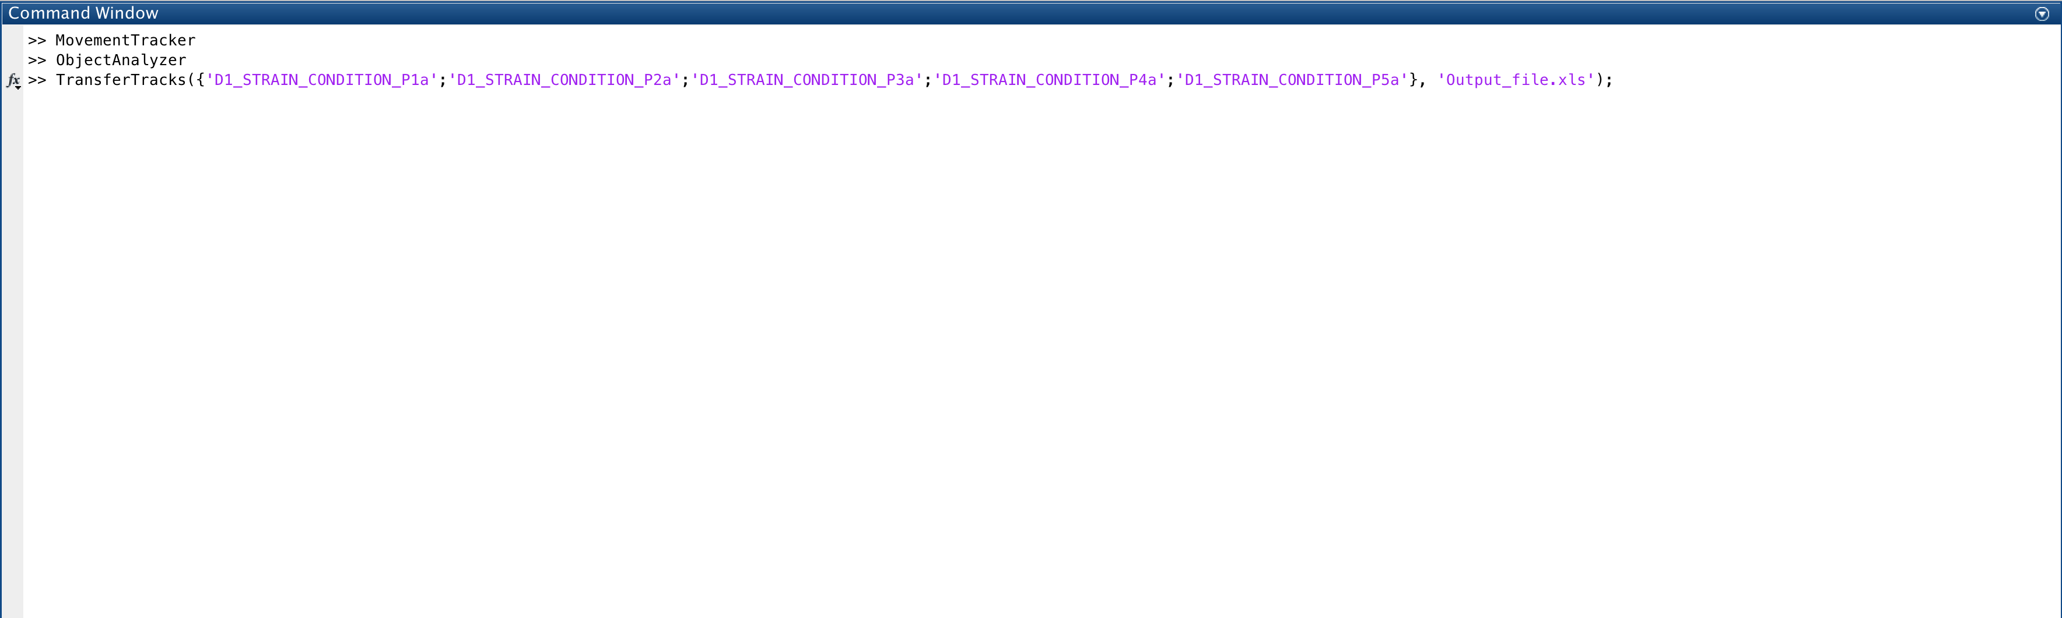TransferTracks( { ‘Video_Condition1_P1a.mat’ ; ‘Video_Condition1_P2a.mat’ ; ‘Video_Condition2_P1a.mat’; ... } , 'Output_File.xls' )

where Video_Condition1_P1a.mat … etc are the output files from the ObjectAnalyzer and Output_File.xls is the file name in which you want to display the results. In a few seconds, the output Excel file will be generated and saved in your MATLAB working directory.

In this file, you can view summary information about each plate/chamber and each object that was tracked.

You get the following information in a four sheet document, of which Sheet 1 is probably of chief interest:

Sheet 1: Summary information for each individual in each plate/chamber, giving one value for each in:

-Object Number Identify each individual of the plate/chamber

-Speed Mean velocity of the object over the track

-Distance Calculated as the area under the curve of speed over a fixed interval

-Size Average size of the object.

-Direction The time the object moved in positive direction (up or right) or in negative direction (down or left)

-Angular Speed Mean angular velocity of the object over the track

-AngularDistance The overall amount of turning by the object

An example sheet with the obtainable information is provided below for the worm setup on solid medium:

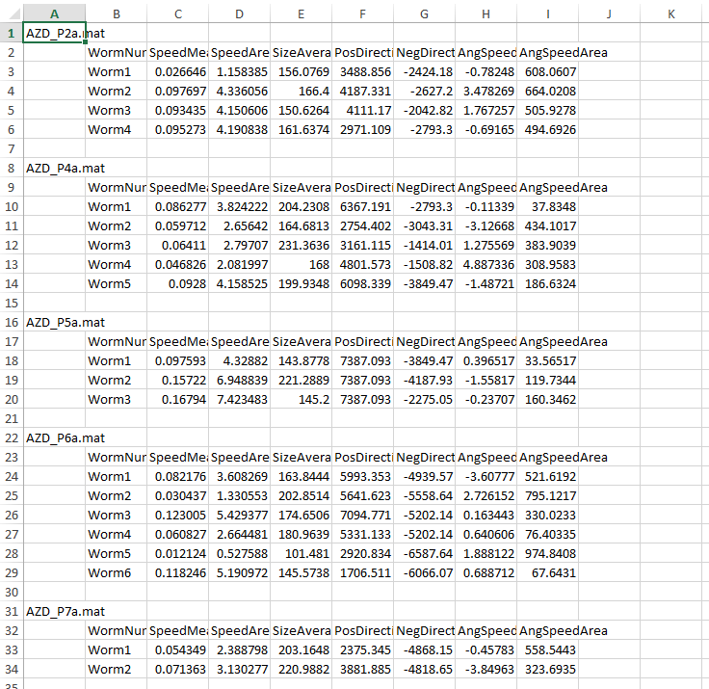

Sheet 2: Contains the raw data vectors of speed for each worm.

Sheet 3: Contains the raw data vectors of angular speed for each worm

Sheet 4: Contains the raw data vectors of direction for each worm

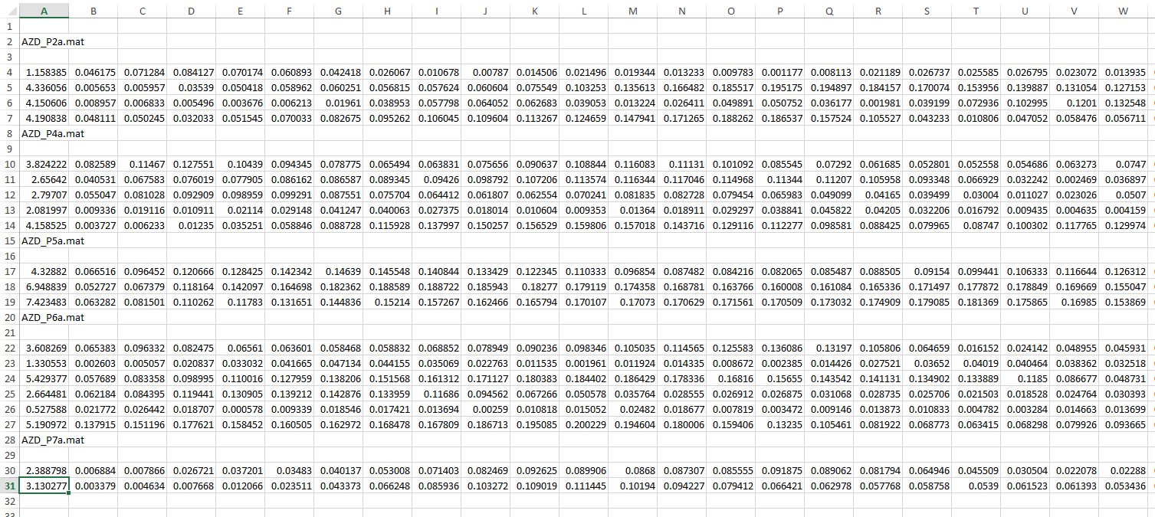

**VIII) TroubleShooting:**

No specialty in programming or MATLAB is necessary to set up the MovementTracker, although familiarity will help initial potential issues (e.g. where does the command window go if someone accidentally closes it). Once initial setup for each experimental condition type (e.g. solid tracking, liquid tracking) is established, teaching new users the program is quite fast; however establishing guidelines for these conditions may take some time.

1. VIDEO CAPTURE

The most common problem with video capture is choosing the correct settings. Most users will, by default, try to acquire the “highest quality” video using the best framerate, highest resolution, moderate contrast, and moderate zoom. While such videos make good presentations, they are actually non-ideal for computerized analysis. Low framerate, low resolution, extremely high contrast, and low zoom will provide the most (and best) results for this tracker. Some hands-on experience may be necessary to find the best settings for your setup.

Take note to not include special characters in the video names (e.g. + / & , and we recommend using underscore (_) instead of space ( )). Special characters may cause system incompatibles or other errors. Also, the numerical indicator at the end of the video must follow a letter, e.g. “Day2_N2_Plate1” and “Day2_N2_Plate2” are a valid series, while “Day2_N2_1” and “Day2_N2_2” will give an error.

• How to best record videos?

* We get the best results for the MovementTracker on solid medium under a bright field microscope with contrast turned to maximum: i.e. very black worms on a very white background. For this reason, a wide field of view at a low resolution (e.g. 640x480) often gives better results, as coloration differences inside the worm are no longer apparent, and more worms can be tracked simultaneously on a single, large plate (we generally use 10 worms on a 35mm dish).
* We generally get the best results for *demonstration purposes* at a relatively high magnification and small field of view, showing 3–4 worms at moderate contrast and high resolution (1280x960); the MovementTracker still works fine for such cases, but it is slower and gives fewer tracks.

• How to best record worms in liquid medium?

* Worms in liquid generally move much faster than in solid medium, and contrast is generally worse. Frame rate should be increased to 2-4 frames per second, as otherwise worms may “blur” too much.
* Worms will also likely intersect and overlap more often in liquid medium, and due to this and the increase in speed, it may be necessary to use fewer worms. Also take care that the liquid-filled object is truly flat: many liquid-medium plates are slightly concave, which will result in worms “clumping” in the middle and becoming indistinguishable to the software.

• What should I do if I want to change the zoom, contrast, time length of recording, frame rate, or other settings from the default used by my laboratory?

* Several preferences will have to be changed in the MovementTracker software:

— Zoom will change:

(A) the pixels-per-mm; to recalibrate, put a ruler under the microscope at your target zoom level, then take a screenshot and count how many pixels per mm.

(B) The apparent size of the object: thus you will have to take a new ‘minimum’ and ‘maximum’ object size; either estimated by trial and error, or by looking at screenshots and counting pixels. If counting pixels, use the “plot color-coded objects” tool to see exactly which pixels are considered ‘objects’. Note that a very wide range can be used here, but allowing very small objects (e.g. < 40 pixels) will result in many “false positive” tracks that will need to be deleted in the ObjectAnalyzer.

(C) The “max distance travelled by object between successive frames” and “max size change by object” – again these can be measured in screenshots, or just estimated by feel.

• Contrast will change:

(A) The auto thresholding correction value. Lower imaging contrast means higher values should be used. Higher contrast means lower values should be used. You can guess and check here, but most values will fall between 0 and 0.2.

— Time length of recording will change:

(A) By default, NOTHING, unless you record under 45 frames of video, at which point the software will not work without other modifications. This is because, by default, the ObjectAnalyzer and TransferTracks scan through videos for all tracks which are recorded for at least 45 frames worth of data, then all parameters will be calculated based on these 45 frames (even if more frames of data are recorded for an individual, only the first 45 will be used). This is because if one object has a 45 frame track, and another one a 60 frame track, the distance the 45-frame-track worm moves will likely be less than the 60-frame-track object but for artificial reasons. Thus, the 60 frame object will be considered for only its first 45 frames of movement. These parameters can be changed if necessary: for old animals, for example, longer recordings may be necessary, while for liquid setups, shorter recordings may be necessary.

— Frame rate will change:

Nothing; however, objects recorded at 2 fps should not be **directly** compared to those recorded at 1 fps, and cannot be analyzed in the MovementTracker at the same time. If analyzed separately, the results from the ObjectAnalyzer CAN be compared, but only after mathematical changes. E.g. an object recorded at 2 fps might move 5.3 units over 45 frames, while the same object recorded at 1 fps would move 10.6 units over 45 frames.

— Video quality will change:

Increasing the image quality will make no changes (except an increase in file size and processing time); increasing the resolution will change all of the pixel values. E.g. a worm which is 230 pixels in a 640x480 video will become 920 pixels in a 1280x960 video; a length of 42 pixels/mm will become 168 pixels/mm and so forth.

Take special care when modifying frame rate or recording length, as such changes could potentially make old and new datasets, recorded differently, difficult or impossible to directly compare.

1. MOVEMENT TRACKER

The MovementTracker itself is fairly straightforward once videos have been optimized and the default preferences set. Issues related to changing the zoom, video framerate, and image quality are discussed previously. We recommend creating a standard protocol for everyone in the lab to follow to limit the number of different (and possibly mutually-exclusive) settings. Be sure to create explicitly-detailed works, right down to contrast (e.g. “turn the light knob all the way to maximum”).

(C) OBJECT ANALYZER

By this stage, few problems are encountered, but some minor issues include:

• I get an error when trying to open a tracks file.

* Probably the tracks file is empty (i.e. no tracks were considered valid according to the parameters used in MovementTracker – note that just because you see blue crosses does not mean the track is valid; such tracks did not meet the “shortest valid track” criteria). If this occurs with one file, we recommend deleting it (and re-recording the video for that plate, or skipping it). If this is a persistent issue with many plates/chambers, there is either a problem with the videos themselves or the MovementTracker criteria are too stringent or incorrectly selected.

• I have deleted a valid track; how do I recover it? (Alternately: I saved a tracks file with an invalid track)

* Just re-open the tracks file and analyze it again.

• My tracks slider disappeared and I can’t delete the last track.

–  This is because you have deleted the last track and a bug prevents the slider from reappearing. This is OK—just analyze all tracks and if you hit cancel, the slider will re-appear and the last track will be successfully removed. Or you can just save all tracks and go on to the next file.

1. TRANSFER TRACKS

This step is straightforward once you get all the special characters and syntax correct. We recommend copying and pasting as much as possible to eliminate errors, potentially even writing the command in Word and then pasting it in, so that you can more easily note inconsistencies. Curly braces { and } can be kind of hard to find on some languages’ keyboard layouts—just keep looking (or copy and paste from this tutorial)!